LAB 10

**1.** Write a set of action queries coded as a transaction to reflect the following change: “The Drawing Board” has been purchased by “Computer Library” and the new company is named ‘ComputerBoard’. Rename one of the vendors and delete the other after updating the VendorID column in the Invoices table. Use SELECT statement to verify the results.

**Comments:**

The Drawing Board is a set of action queries coded as a transaction to reflect the following change:

Computer Library has acquired it, and the new company is

It is called ComputerBoard, and it renames one of the suppliers before deleting the other.

The VendorID field in the Invoices database is being updated.

**Query:**

If Exists (Select * From sys.triggers Where object_id = OBJECT_ID('Invoices_UPDATE_Shipping'))

Drop Trigger [dbo].[Invoices_UPDATE_Shipping];

Go

Begin Tran;

Update AP.dbo.Invoices Set VendorID = 86 Where VendorID = 85;

Delete AP.dbo.Vendors Where VendorID = 85;

Update AP.dbo.Vendors Set VendorName = 'ComputerBoard' Where VendorID = 86;

Commit Tran;

**Output:**

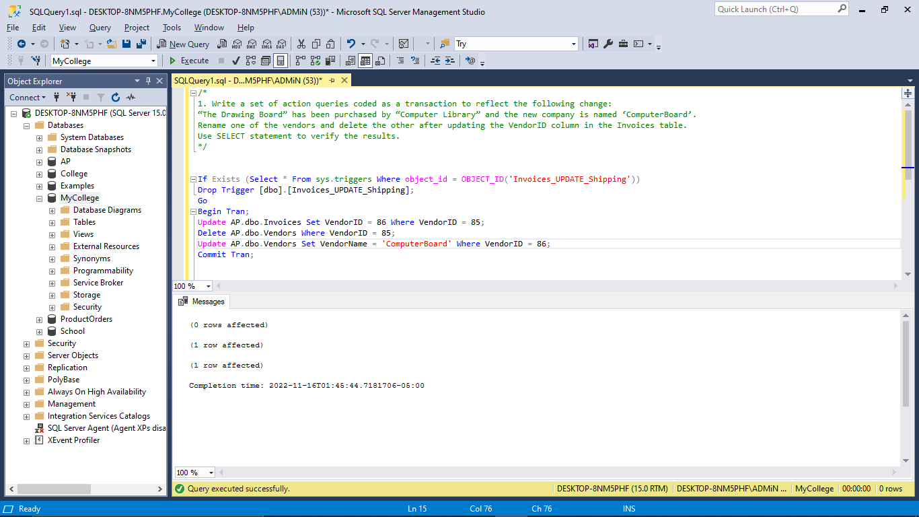

**Query:**

Select * From AP.dbo.Vendors Where VendorID = 86;

Select * From AP.dbo.Vendors Where VendorID = 85;

**Output:**

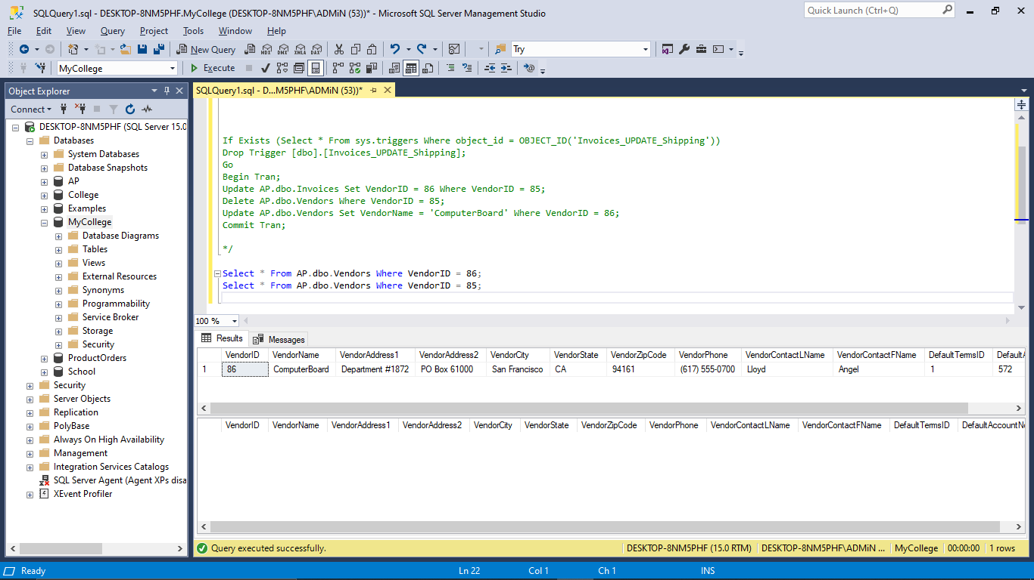

**2.** Write a set of action queries coded as a transaction to move rows from the Invoices table to the InvoiceArchive table. Insert all paid invoices from Invoices into InvoiceArchive, but only if the invoice doesn’t already exist in the InvoiceArchive table. Then, delete all paid invoices from the Invoices table, but only if the invoice exists in the InvoiceArchive table. Use SELECT statement to verify the results.

**Comments:**

A set of transaction-coded action queries to move rows from the Invoices table to the InvoiceArchive table. It inserts all paid invoices from Invoices into the InvoiceArchive table if the invoice does not already exist there, and then deletes all paid invoices from the Invoices table if the invoice already exists in the InvoiceArchive table.

**Query:**

Begin Tran;

Insert AP.dbo.InvoiceArchive Select I.* From AP.dbo.Invoices As I Left Join AP.dbo.InvoiceArchive As IA On I.InvoiceID = IA.InvoiceID

Where I.InvoiceTotal - I.CreditTotal - I.PaymentTotal = 0 And IA.InvoiceID Is Null;

Delete AP.dbo.Invoices Where InvoiceID In (Select InvoiceID From AP.dbo.InvoiceArchive);

Commit Tran;

**Output:**

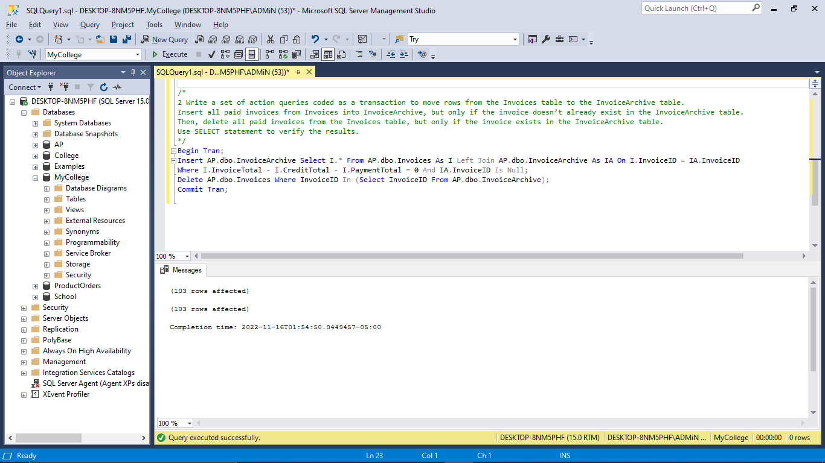

**Query:**

Select * From AP.dbo.Invoices;

Select * From AP.dbo.InvoiceArchive;

Select * From AP.dbo.Invoices Join AP.dbo.InvoiceArchive On Invoices.InvoiceID = InvoiceArchive.InvoiceID;

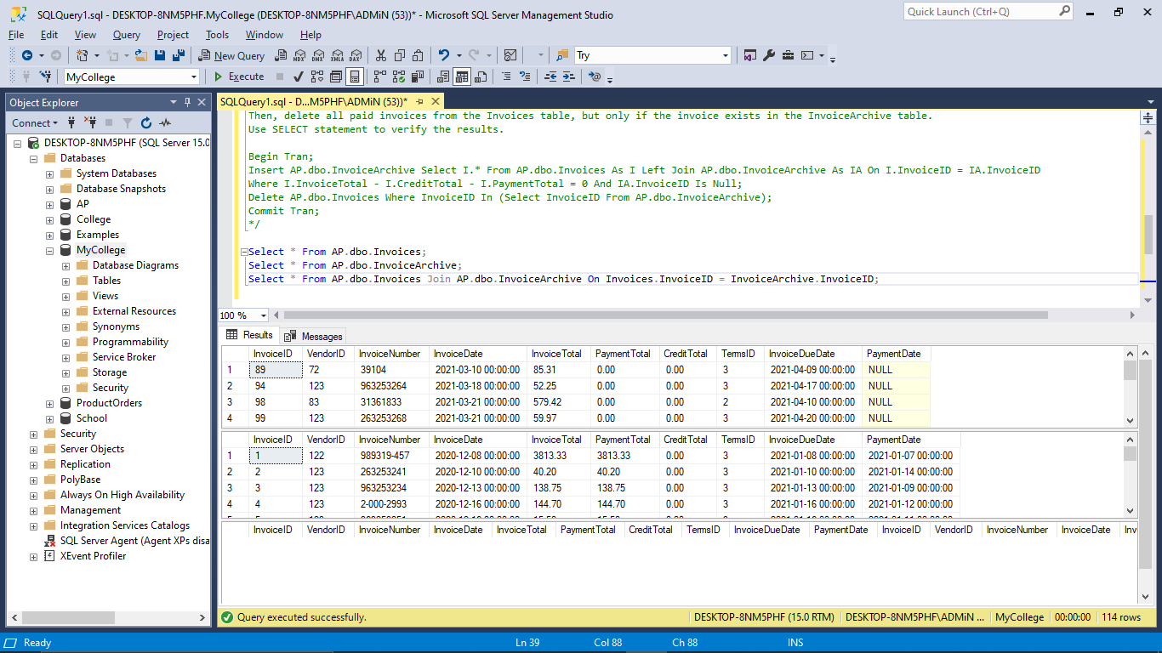

## Remarks for the lab:

This Lab consisted the utilization of transactions and locks